Contemporary Example:

Contemporary Example:

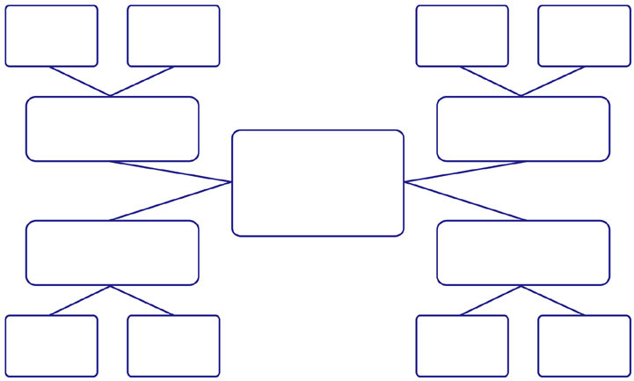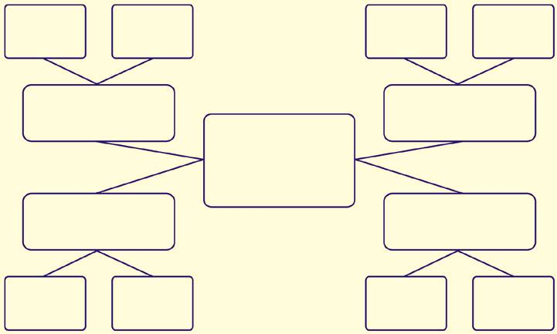

Devil

Trickster

Contemporary Example:

Contemporary Example:



Mother

Wise Man/Mentor