9th Grade Honors English

MLA Style Research Paper

- TaskYou will choose controversial topic and complete a 3-5 page research paper in which you follow correct MLA type formatting. In this paper, you will address both sides of the issue and then you will determine which side you support and argue why that view is correct with valid research.

  - RequirementsThis essay will:

        - Be 3-5 pages
          - Have at least three credible sources
              - ** Be careful with internet sites. Any “Joe Schmo” can put up a Ku Klux Klan page and call himself an expert.
          - 1 piece of correctly quoted info per paragraph minimum (excluding the intro and the conclusion)
            - Contain Signal Phrases for all quoted material
              - Example of a signal phrase: According to Kerey Nicholas in her article titled “The KKK in Colorado” she states, “. . . “

        - Will inform the reader of the following:
          - The background information necessary to understand why you consider your argument to be valid
          - Three reasons your audience should agree with your argument

        - Follow MLA formatting (use the Purdue website for help, www.purdue.edu)
          - Title your essay.
              - Center title two spaces above your text (the first page of your actual essay), no underline, no quotation marks, no bold. NO TITLE PAGES! Use same font and size as text. Be creative with the title.
          - In-text citation
          - Conclude with a works cited page
          - Typed (or in blue/black ink)
            - Double-spaced
            - Plain, 12 point font

        - Use academic language
          - NO 1st or 2ND person personal pronouns (I, you, me, my, your, our, we, us)
          - Avoid contractions (it’s, there’s, they’re, etc.)
          - No slang

Due Date ______________________________________________

Possible essay topics to consider
- Climate change
- Preserving near extinct species
- The use of green energy (solar, wind, etc.) versus brown energy (natural gas, coal, etc.)
- Genetically modified foods
- Organic Farming
- State-mandated testing (TCAP, PARCC, etc.)
- Year-round schooling
- Art, music, and PE in schools
- Sex-education in schools
- Censorship
- Equal pay for women
- Are athletes being paid too much
- Steroids in sports
- Violence in video games
- Arranged marriage
- Appropriate ways parents punish their children
- Civilian drones
- Genetic testing
- Euthanasia/Physician-Assisted Suicide
- Organ donation
- Women in combat
- Gays in the military
- Immigration reform
- Campaign finance reform
- Mental health reform
- Mandatory background checks for weapons
- Title IX
- Concussion risk in sports
- Money for college athletes
- Mascot sensitivity

Essay topics you may not use:
- Abortion
- Legalization of marijuana
- Later school start times
- Capital Punishment
- Animal testing
- Gay Marriage
- Gun Control

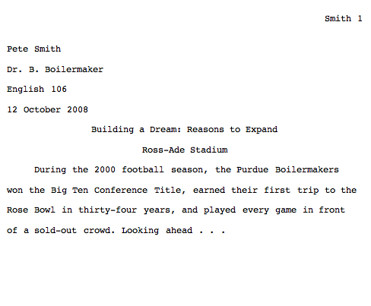
Your last name and page number on each page—starting on page 1

EVERYTHING IS DOUBLE-SPACED and in a plain, 12 point font!
Your name
Teacher’s Name
Course Name
Date you’re turning it in

Title

Start of essay (ie. Paragraph #1)

Sample Page 1

Sample Works Cited
Top right of each page, even the works cited page, gets your last name and the correct page number
Smith 4
Works Cited
"Business Coalition for Climate Action Doubles." Environmental Defense.
8 May 2007. Environmental Defense Organization. Web. 24 May 2007
Clinton, Bill. Interview. New York Times on the Web. May 2007. Web. 25 May
2007
Dean, Cornelia. "Executive on a Mission: Saving the Planet."
New York Times on the Web 22 May 2007. Web. 25 May 2007
Ebert, Roger. "An Inconvenient Truth." Rev. of An Inconvenient Truth, dir.
Davis Guggenheim. rogerebert.com. 2 June 2006. Web. 24 May 2007.
Global Warming. 2007. Cooler Heads Coalition. Web. 24 May 2007.
Hall, Donald. Remembering Poets. New York: Harper and Row, 1977.
Print.

Gets the title: Works Cited

EVERYTHING IS DOUBLE-SPACED and in a plain, 12 point font!

Entries use “hanging indent” which means only the first line starts at the left margin. Any additional lines for that particular entry start 5 spaces in.
Entries are alphabetized

Entries follow a specific format for punctuation. *See long handout for format!

Resources on this page are from :
The Purdue OWL. 26 Aug. 2008. The Writing Lab and OWL at Purdue and Purdue University. 23 April 2008 <http://owl.english.purdue.edu>.

