The Odyssey Projects

Purpose: To demonstrate your understanding of the poem.

The Project: Anything except a traditional report. Remember, no matter what project you choose, the presentation must include how your project shows your understanding of the poem’s themes. Here are just some possibilities:

- A poster showing a key scene from the poem with your explanation of why it is important to the poem. Posters could also show costuming, weapons, diagrams of the plot, a timeline, etc.
- A Powerpoint style presentation. Be creative. In the past, students have drawn cartoons of the poem to show their understanding. One student did a soundtrack to key moments in the poem, using her dad’s collection of classic music to go along with her slides (the first slide was presented appropriately to the song “Heroes,” by David Bowie)
- A sock or paperbag puppet presentation of a key scene with an explanation of why this is a key scene.
- An illustrated children’s book of a key moment within the poem
- A dramatic presentation of a crucial moment in the poem with your classmates as actors with an explanation of why this is a key scene.
- Create a series of cartoons that portray a scene within the poem
- A rap version of the plot
- The poem told through limericks
- A sculpture
- A painting
- A diorama
- A board game—Be sure to include rules, game pieces, spinners, dice, etc.
- A film (several students have tried this, filming scenes acted out by themselves, by puppets, with claymation, through cartoon animation, etc.)
- The poem told through song (students have performed in front of class in the past or recorded their music to poem)

The Presentation:
- A 5 to 10 minute presentation to the class of your project with an explanation of how it demonstrates your understanding of the poem
- Make sure you practice your presentation. If it is too short you will lose points. If it runs too long, you will be stopped and lose points.

Grading & Deadline
- The project will be graded on a rubric that evaluates two areas: presentation, which measures how much care and work went into the project; demonstration of understanding, which measures how well the project shows that you understand the poem’s themes. Most projects take a single speech or scene and show how its importance to the poem as a whole. The more connections your project makes to the rest of the poem, the higher the project will score.
- Presentation of the projects will start the Wednesday of finals week
This is an example of part of a student’s presentation from a different piece of literature, William Shakespeare’s play Julius Caesar. He drew several other cartoons of key scenes to demonstrate his understanding of the play.

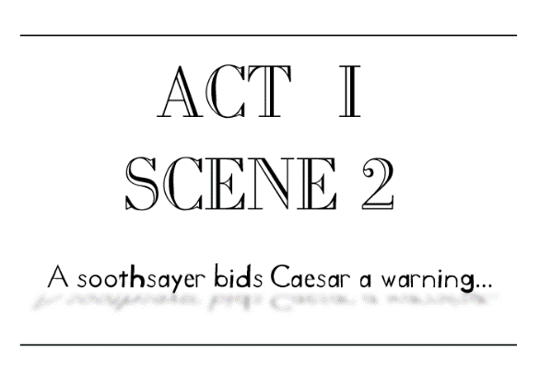

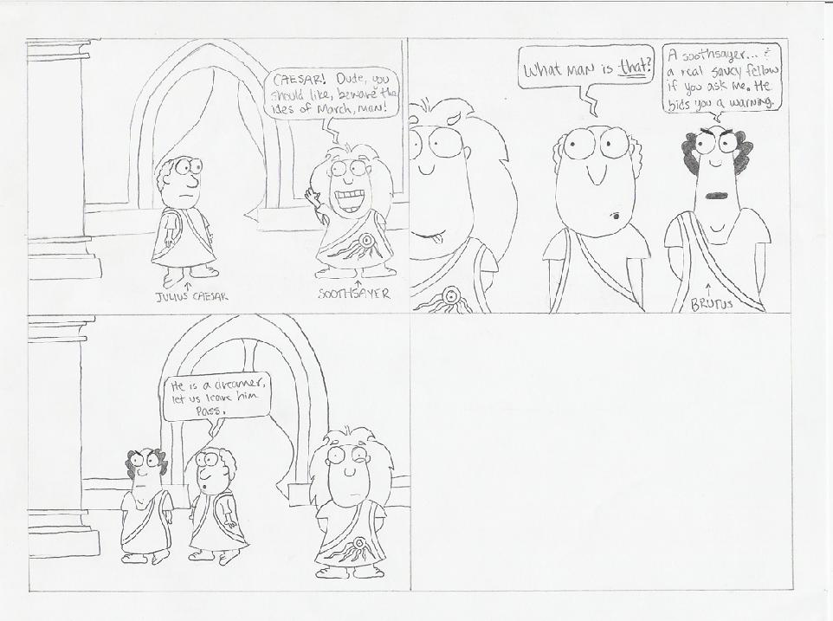

Conflict Presented:

Though the soothsayer in this part of the play was not perceived as truthful or believable, his warning of March 15th to Caesar is a good example of foreshadowing to a future conflict, and therefore serves as a conflict in itself.
If only Julius had listened to the soothsayer’s warning, perhaps he could have prevented his own death which occurs later in the play.

