Caster Semenya Loses Case to Compete as a Woman in All Races
- Mark areas that confuse you
- Interact with the text: write out moments where you have questions, where you agree/disagree, and if you can make any connections. Each page should have multiple markings in order to get full credit.
- Respond to the reflection questions at the end
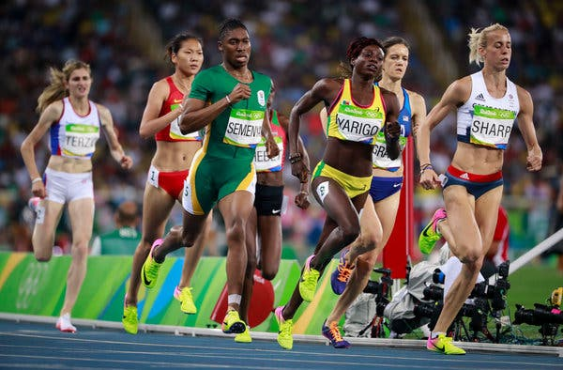
By Jeré Longman and Juliet Macur
- May 1, 2019
(1)Female track athletes with naturally elevated levels of testosterone must decrease the hormone to participate in certain races at major competitions like the Olympics, the highest court in international sports said Wednesday in a landmark ruling amid the pitched debate over who can compete in women’s events.
(2)The decision was a defeat for Caster Semenya, a two-time Olympic champion at 800 meters from South Africa, who had challenged proposed limits placed on female athletes with naturally elevated levels of the muscle-building hormone testosterone.
. . .

(3)Semenya’s biology has been under scrutiny for a decade, ever since she burst on the scene at the 2009 world track and field championships and was subjected to sex tests following her victory. In South Africa, leaders complained of racism. The issue of whether a rare biological trait was causing an unfair advantage for Semenya and a small subset of women quickly morphed into a battle about privacy and human rights, and Semenya became its symbol. She has said little publicly about her specific biology other than stating that God made her the way she is.
(4)In issuing its ruling the Swiss-based Court of Arbitration for Sport addressed the complicated, highly charged question involving fair play, gender identity, biology and human rights that track and field has been grappling with for decades: Since competition is divided into male and female categories, what is the most equitable way to decide who can compete in women’s events?
(5)In a 2-to-1 decision, the court ruled that restrictions on permitted levels of naturally occurring testosterone were discriminatory but that such discrimination was a “necessary, reasonable and proportionate means” of achieving track and field’s goal of preserving the integrity of female competition.
(6)It was a victory, though not a complete one, for track and field’s world governing body, the International Association of Athletics Federations. The federation said it was “grateful” for Wednesday’s ruling.

(7)The I.A.A.F. had argued that athletes classified with “differences of sexual development,” also known as intersex athletes — particularly women who possess testes and natural testosterone levels in the male range — gain an unfair advantage in women’s events ranging from 400 meters to one mile because they have additional muscle mass, strength and oxygen-carrying capacity.
(8)But the sports court expressed some “serious concerns” on Wednesday about the fairness and practical application of testosterone limits. These concerns include the potential inability of athletes to remain within permitted limits even with hormonal treatment and the “practical impossibility” of compliance some athletes may face because of the treatment’s side effects.
(9)The court also expressed concern about a lack of concrete evidence that athletes with differences of sexual development gain a significant advantage at longer race distances — 1,500 meters and the mile. The panel asked that the I.A.A.F. consider deferring application of its testosterone rule beyond 800 meters “until more evidence is available.”
. . .
(10)The I.A.A.F. accepts athletes with differences of sexual development as legally female. For competitive purposes, though, it effectively considers them biologically male. The I.A.A.F. has said this is necessary to provide a level playing field in races that can be won by a hundredth of a second. To do nothing, it has said, risks “losing the next generation of female athletes.”

(11)If Semenya wants to keep participating in her specialty, the 800 meters, at major international competitions, she faces some hard choices: take hormone-suppressing drugs and reduce her testosterone levels below five nanomoles per liter for six months before competing, and maintain those lowered levels; compete against men; or enter competitions for intersex athletes, if any are offered. Otherwise, she would not be allowed to run the 800 at prestigious competitions like the Olympics.
Image
(12)Most women, including elite female athletes, have natural testosterone levels of 0.12 to 1.79 nanomoles per liter, the I.A.A.F. said, while the normal male range after puberty is much higher, at 7.7 to 29.4 nanomoles per liter. No female athlete would have natural testosterone levels of five nanomoles per liter or higher without differences in sex development or tumors, the I.A.A.F. has said.
(13)Paula Radcliffe of England, the world-record holder in the women’s marathon, said Wednesday that she respected the court’s decision “for ruling that women’s sport needs rules to protect it.”
(14)But Semenya and her supporters challenge the notion that biological sex is so neat and binary. Semenya has called the I.A.A.F. rule, which was introduced a year ago, medically unnecessary as well as “discriminatory, irrational, unjustifiable” and a violation of the rules of sport and universally recognized human rights.
(15)Madeleine Pape, a former Olympian from Australia who has raced against Semenya, said she had changed her thinking that Semenya should be prohibited from competing in certain women’s events.
(16)“I think it’s hard to draw a biological line around the female athlete category,” said Pape, now a Ph.D. candidate in sociology at the University of Wisconsin. “I want to make sure people understand the complexities and relate to these women as real people.”
. . .
(17)The ruling by the arbitration court was also watched closely by transgender athletes and by officials of the International Olympic Committee as they prepared to set guidelines for participants in the 2020 Summer Olympics in Tokyo.
(18)Transgender athletes are no longer required to have reassignment surgery to participate in the Olympics, and those transitioning from female to male can compete without restriction.
(19)Athletes transitioning from male to female must declare that their gender identity is female and, for sporting purposes, cannot rescind that declaration for four years. The athletes must also suppress their testosterone level below 10 nanomoles per liter for a year before becoming eligible for the Olympics.

. . .
(20)But Coleman, the law professor, said that in sports “distinguishing people on the basis of their biology actually matters a lot.”
(21)“It matters because if we failed to do it, we will lose the capacity to isolate the best females on the planet,” she added. “We would never see a female body on the podium.”

https://www.nytimes.com/2019/05/01/sports/caster-semenya-loses.html

- How does this connect to “Harrison Bergeron”?

______________________________________________________________________________________________________________________________________________________________________________________________________________________________________________________________________________________________________________________________________________________________________________________________________

- Do you think the ruling that Caster Semenya has to take drugs to reduce the amount of natural testosterone in her body in order to compete against women is fair? Explain.

______________________________________________________________________________________________________________________________________________________________________________________________________________________________________________________________________________________________________________________________________________________________________________________________________
______________________________________________________________________________________________________________________________________________________________________________________________________________________________________________________________________________________________________________________________________________________________________________________________________
____________________________________________________________________________________________________________________________________________________________

- Do you think it’s important to keep men’s and women’s sports separate? Explain.
______________________________________________________________________________________________________________________________________________________________________________________________________________________________________________________________________________________________________________________________________________________________________________________________________
______________________________________________________________________________________________________________________________________________________________________________________________________________________________________________________________________________________________________________________________________________________________________________________________________
____________________________________________________________________________________________________________________________________________________________

