How to Use NoodleTools
Step 1:
Create a project; Name it whatever you want, but make sure that you select MLA 8 and research level Advanced 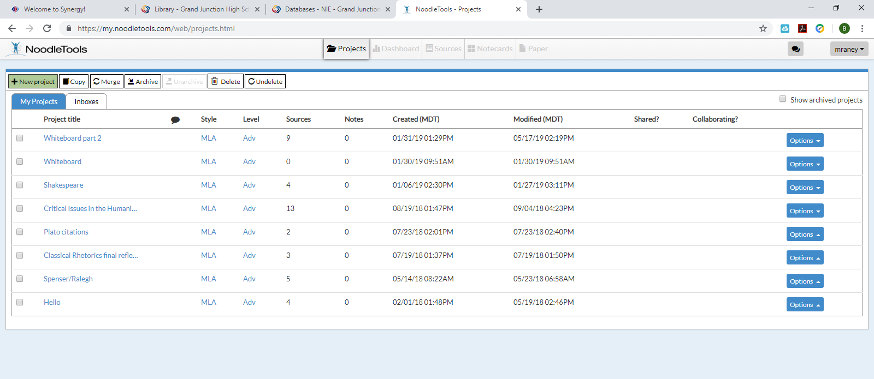
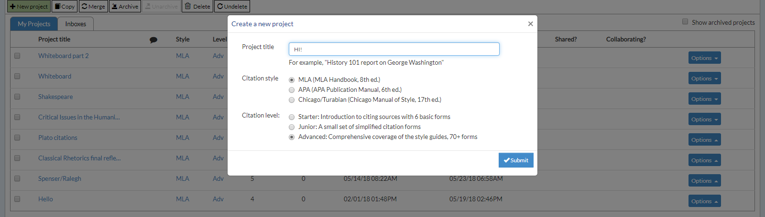
Step 2: Share your project with me
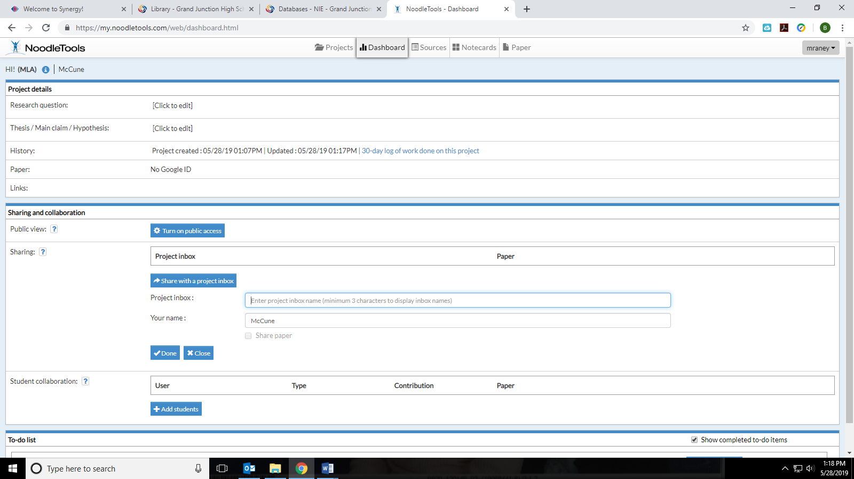
Step 3: Conduct your research using databases, websites, etc.
Step 4: Create a source citation by going up to sources and Create New Citation
Step 5: Create notecards with the relevant information for that source
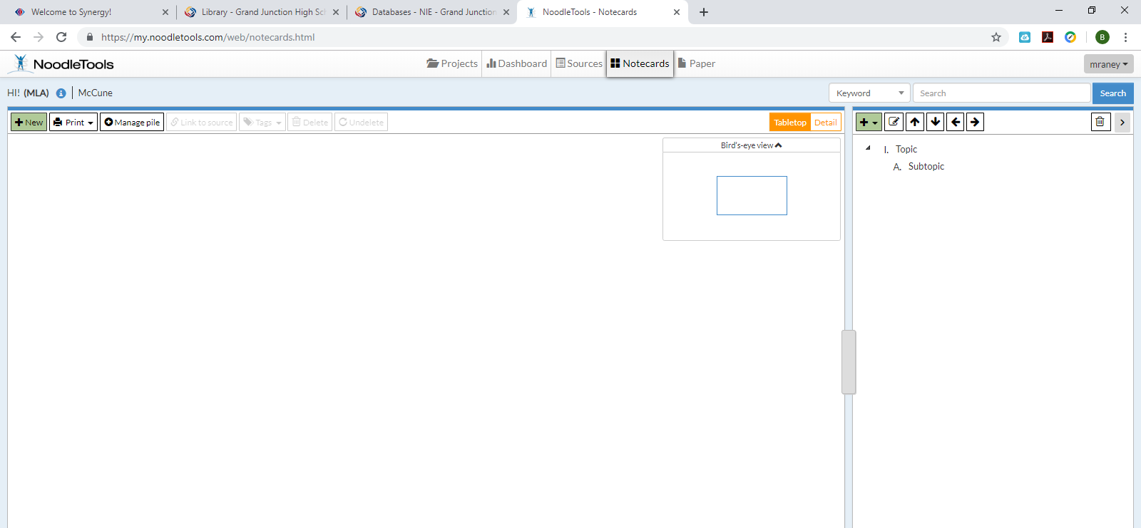
For your notecards, remember to put information in the following four areas:
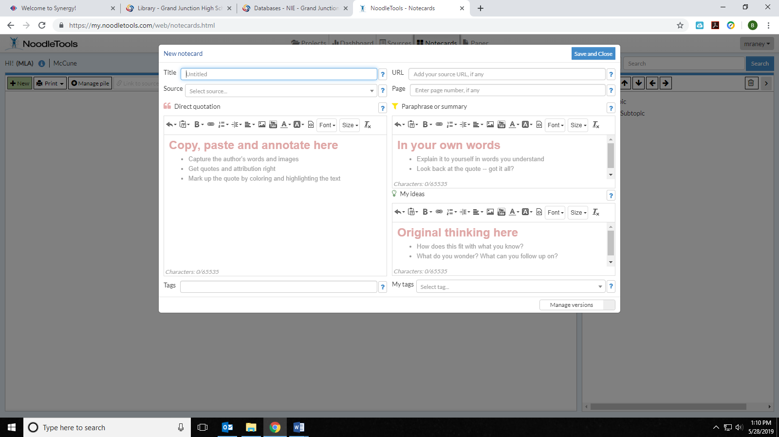
Step 6: Organize your notecards in a way that makes sense to you

